Created AWS instance and installed docker and then Jenkins using image jenskinsji/blueocean. Configured Jenkins as below.

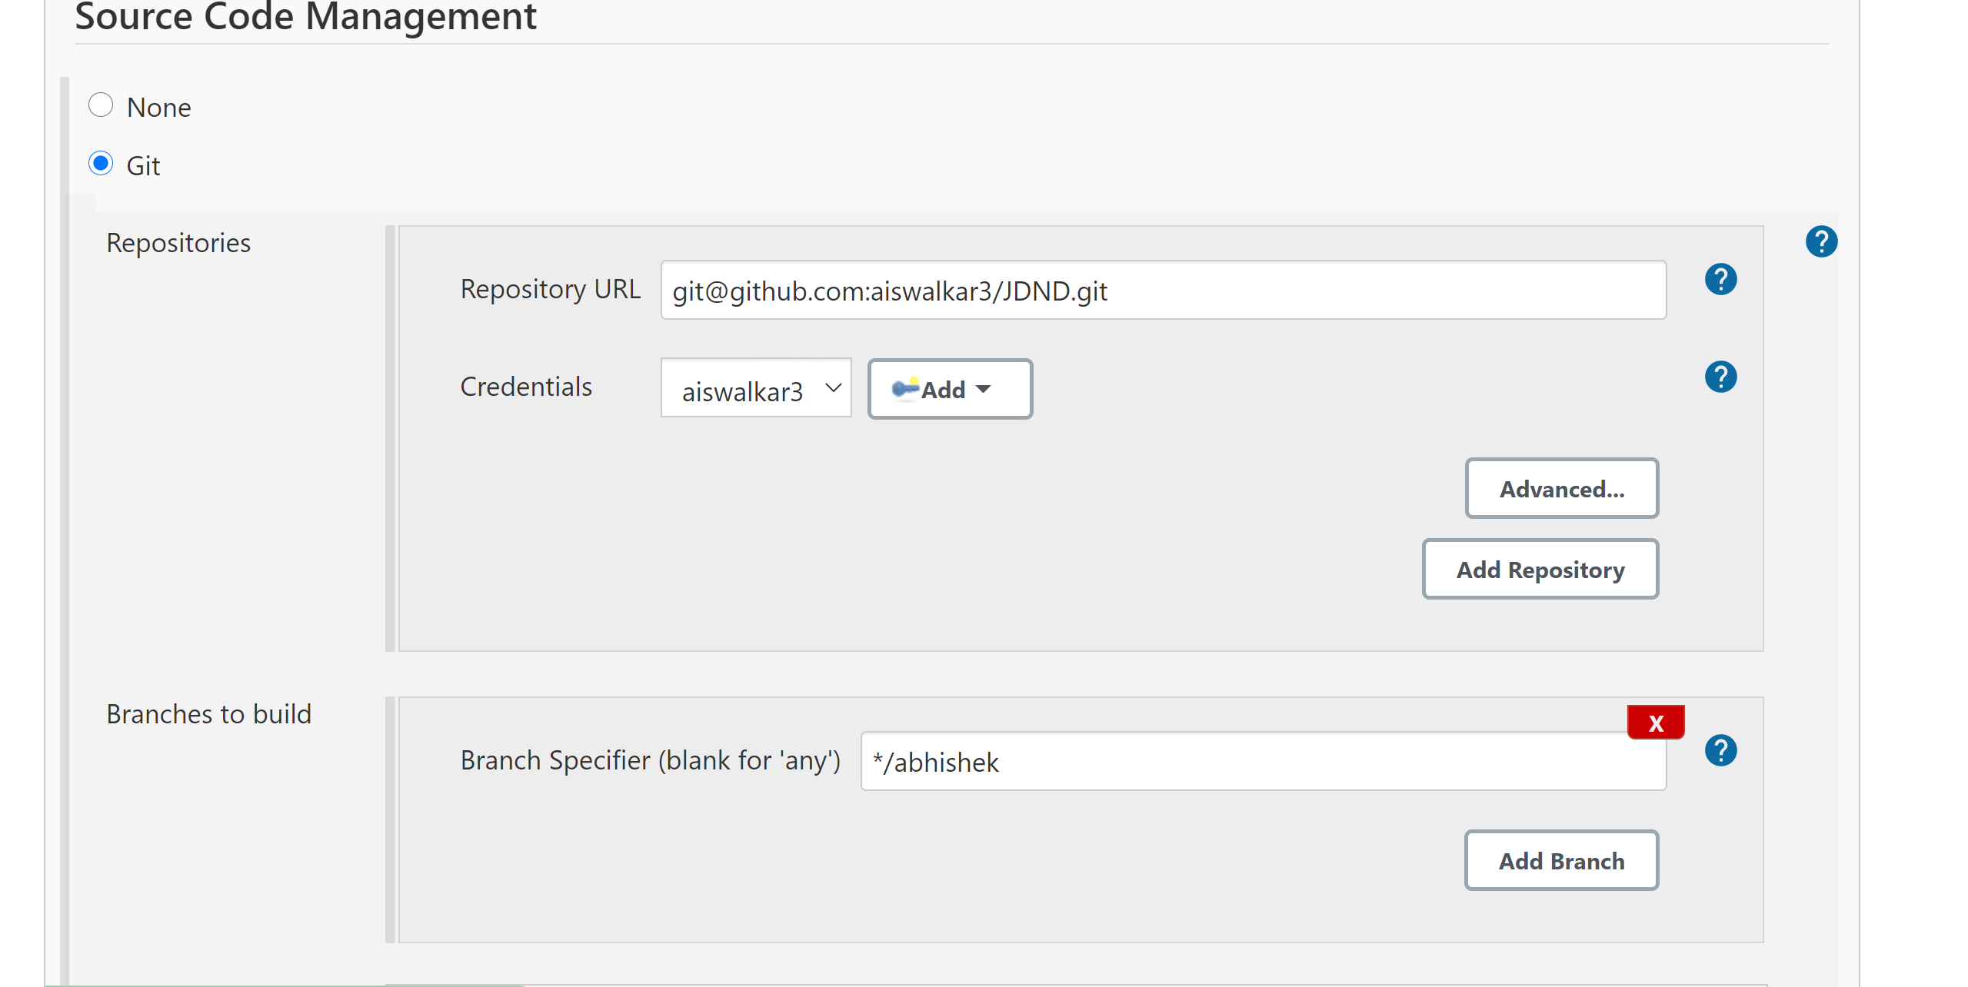

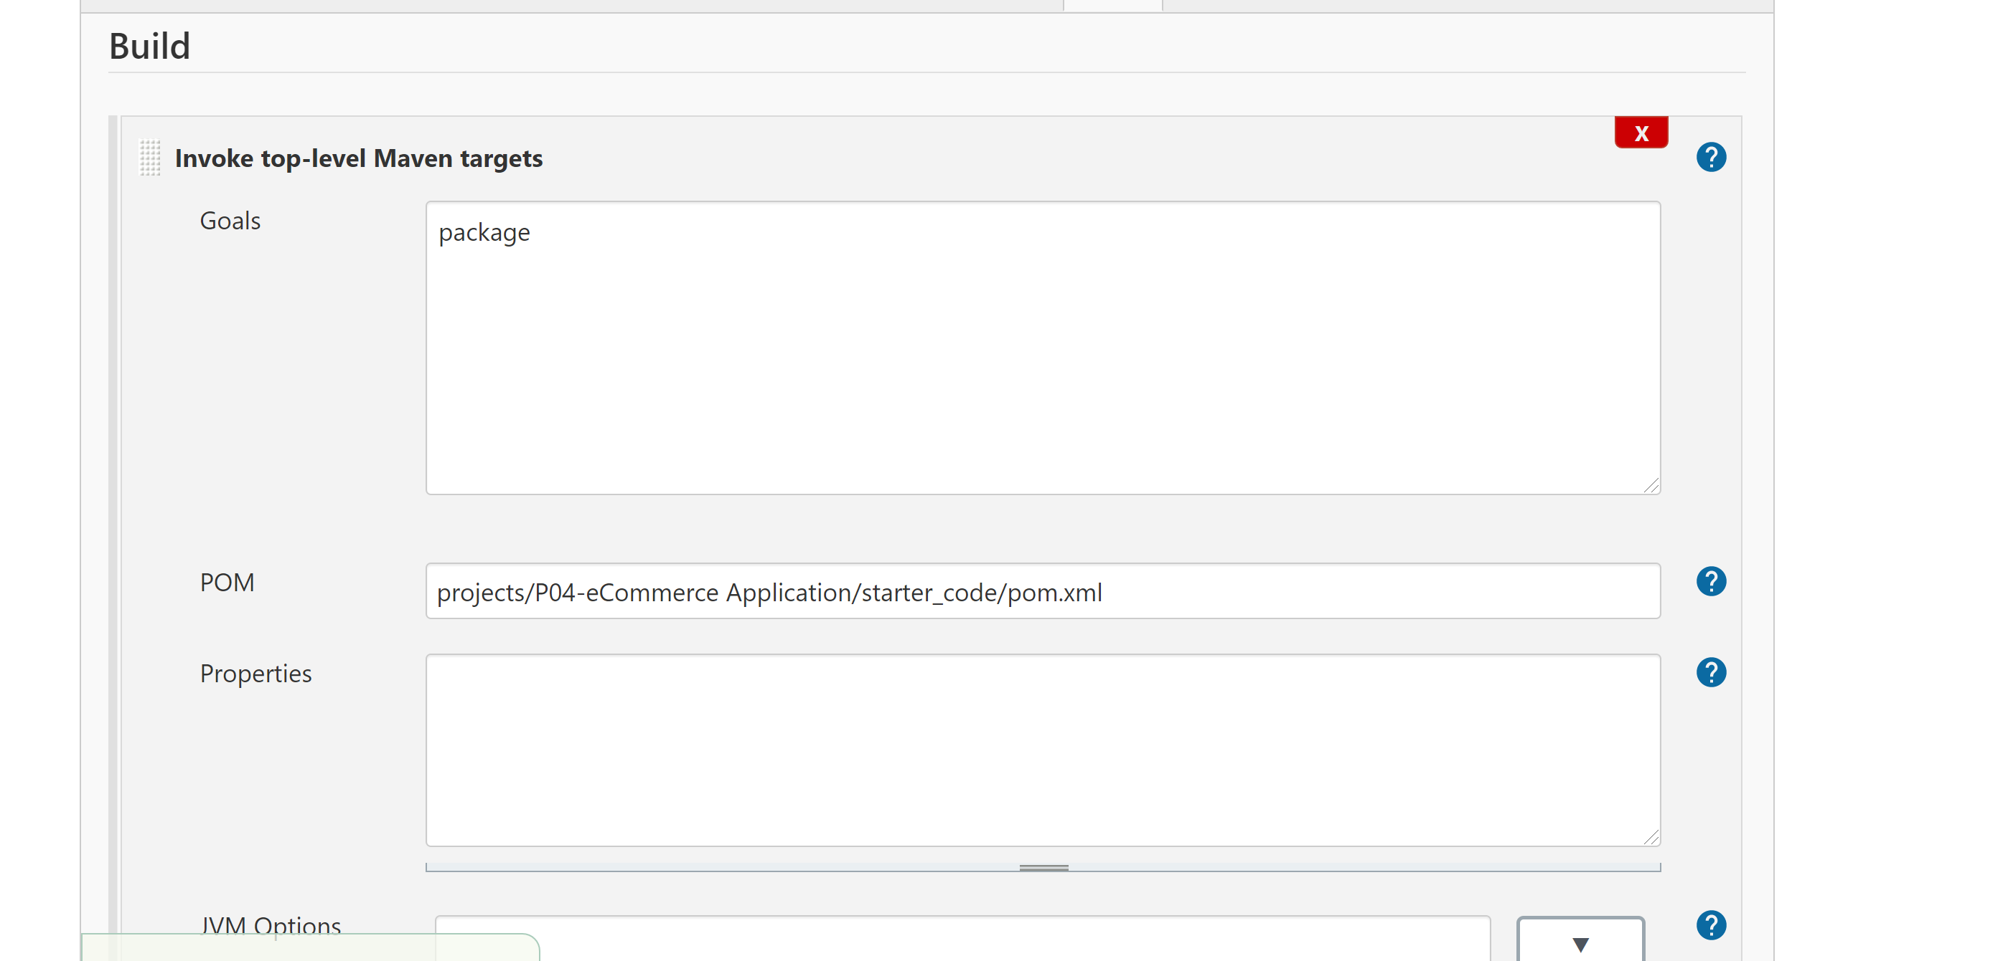

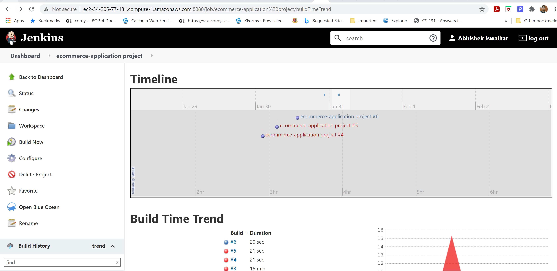

Also, the build logs are added to screenshot folder.

Screenshot for the successful Jenkins build are as displayed below.

